|  |
| --- |
| GR STUDIO |
| Alien Quest |
| **Final Project – Unity Game** |
| Version #02  All work Copyright © 2016 by GR STUDIO.  All rights reserved. |
| **Diego Rodriguez & Jason Gunter** |
|  |

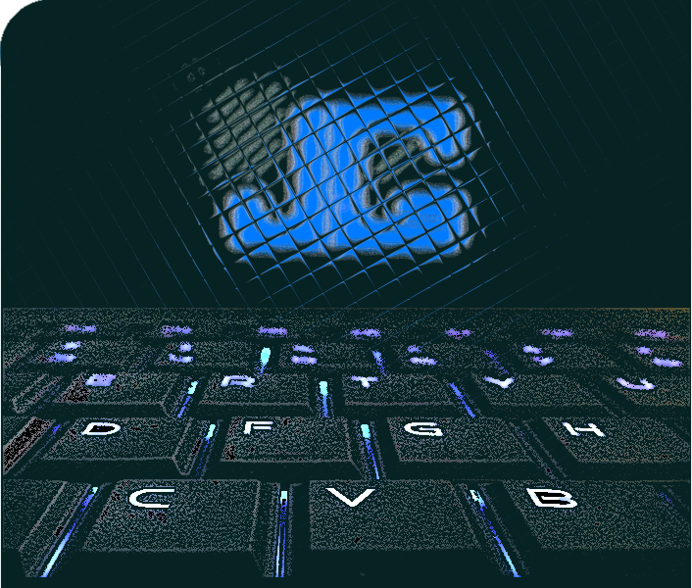

|  |
| --- |
| December 11th, 2016 |

**Table of Contents**

Contents

[**Version History** 3](#_Toc469816415)

[**I.** **Detailed Game Description** 4](#_Toc469816416)

[***II.*** **Controls** 4](#_Toc469816417)

[***III.*** **Interface Sketch** 4](#_Toc469816418)

[**IV.** **Menu and Screen Descriptions** 6](#_Toc469816419)

[**V.** **Levels** 9](#_Toc469816420)

[**VI.** **Characters / Vehicles** 9](#_Toc469816421)

[**VII.** **Enemies** 9](#_Toc469816422)

[**VIII.** **Weapons** 10](#_Toc469816423)

[**IX.** **Scripts** 10](#_Toc469816424)

[***X.*** **Scoring** 10](#_Toc469816425)

[**XI.** **Sound Index** 10](#_Toc469816426)

[**XII.** **Art / Multimedia Index** 11](#_Toc469816427)

# **Version History**

<https://github.com/digma89/Unity2D_Platformer_Alien>

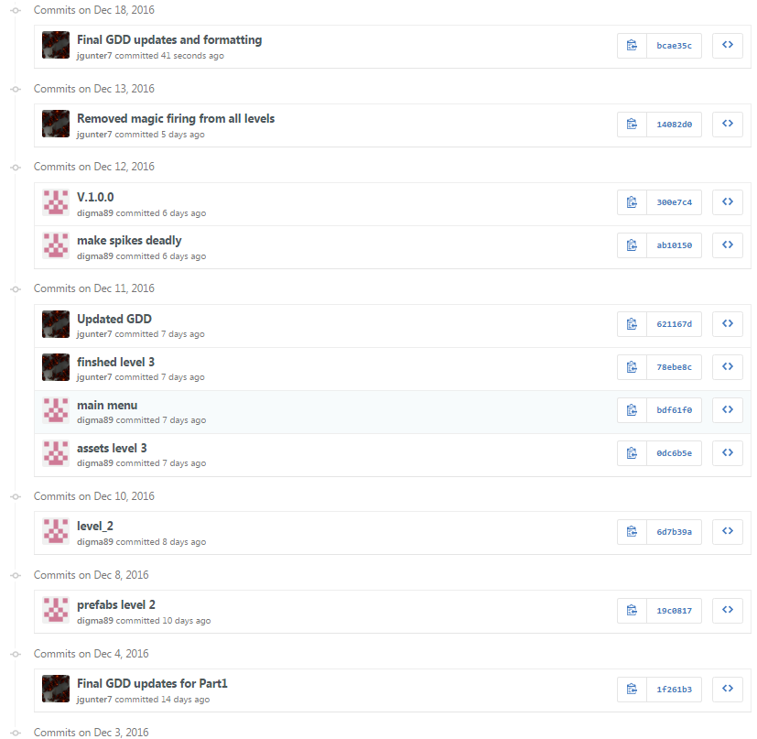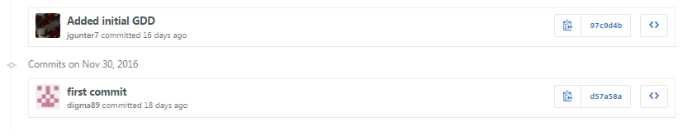

Here is a screenshot from our GitHub repository. This shows our commit history while working on this assignment.

1. **Detailed Game Description**

*The player must avoid enemies, and move across the platforms. The player must escape to the end of each level to win the game. The player should collect coins and can also shoot their weapon at enemies on the platforms. The player will respawn when they fall off the platforms, or hit enemies. The game is over when the player has lost all of their lives, or if they complete all three levels.*

1. **Controls**

*The controls to move the player are default controls (W, A, S, D or arrow keys). Jumping is performed when the player presses the space bar on their keyboard. The player can use the left mouse button or the “CTRL” button to shoot their weapon.*

1. **Interface Sketch**

*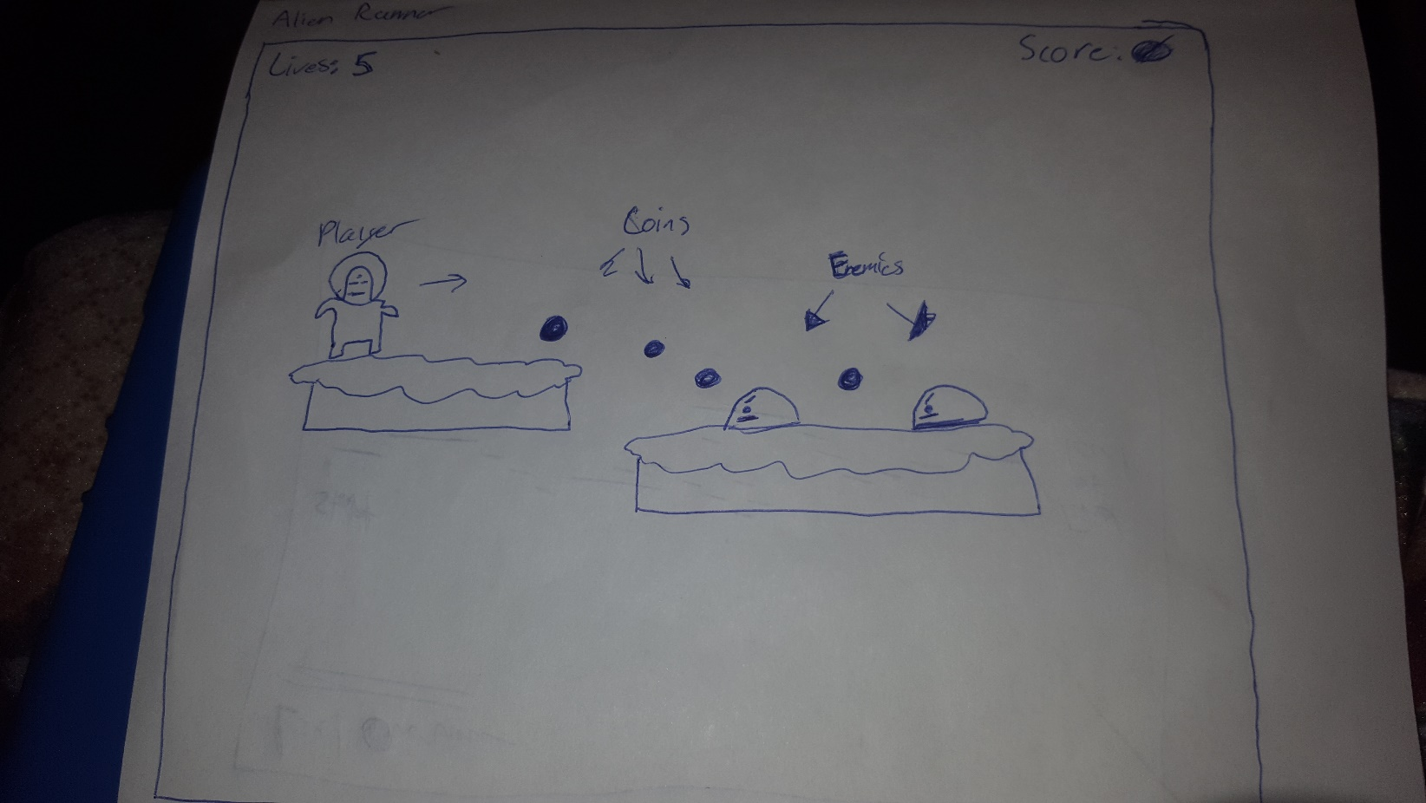*

*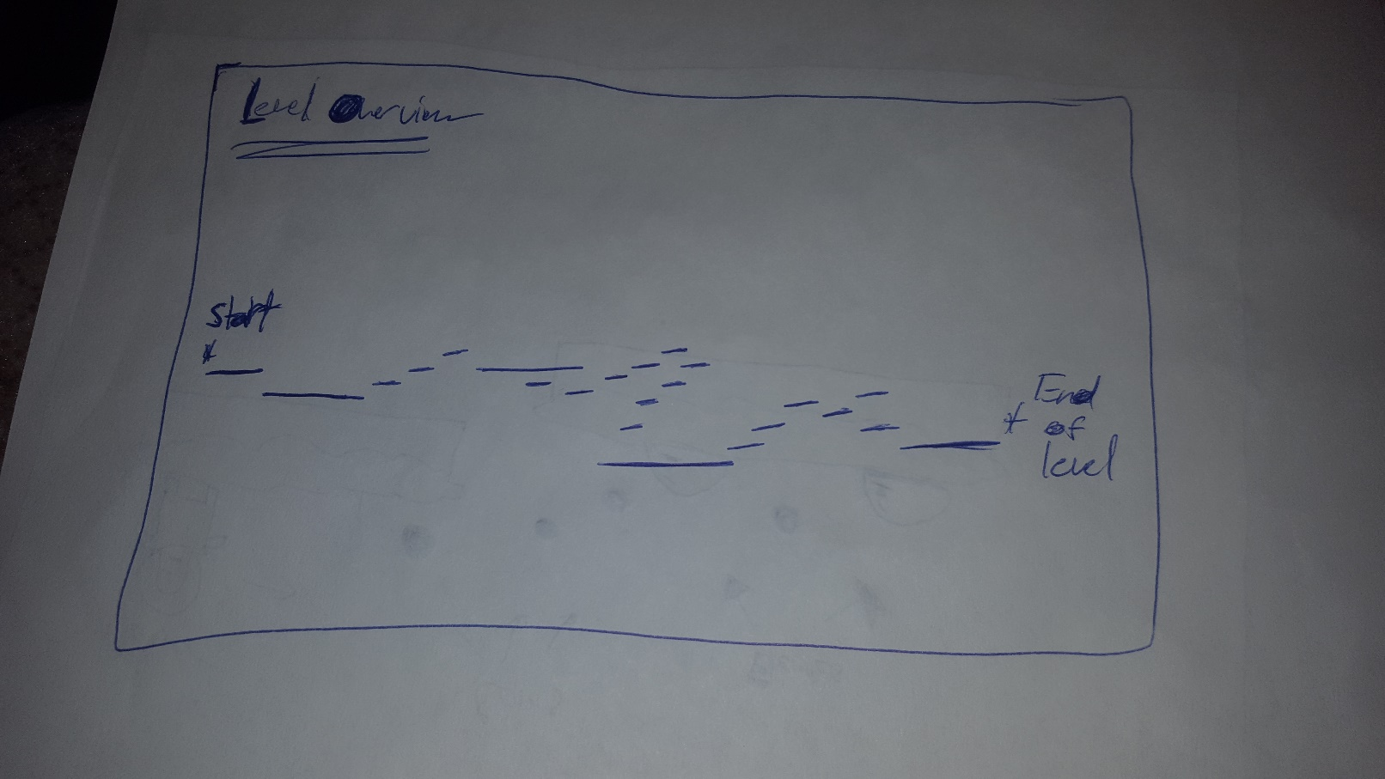*

1. **Menu and Screen Descriptions**

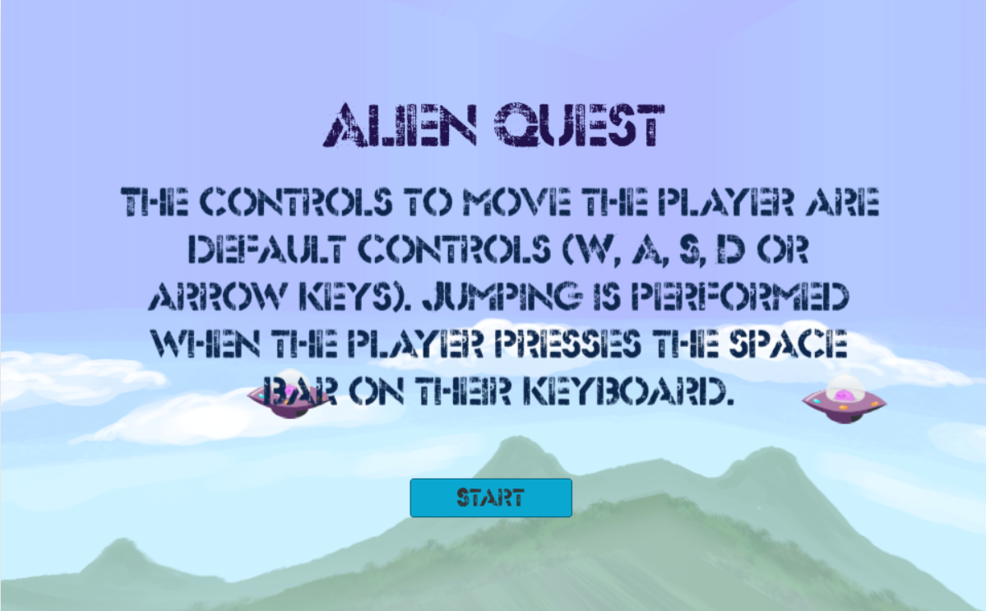

Main menu screen

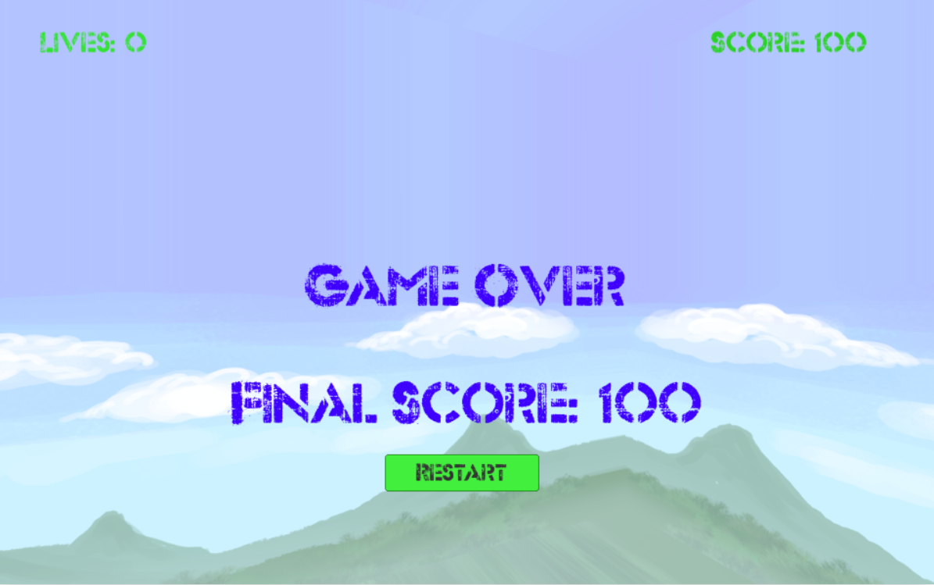Game over screen, with option to restart the level

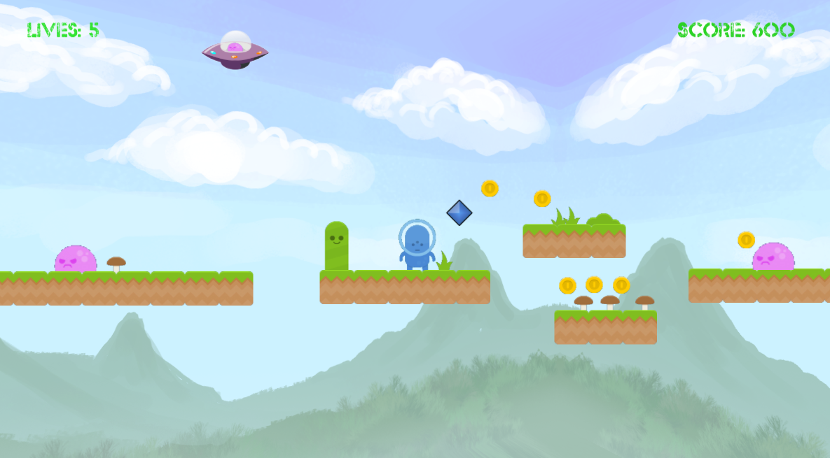

Level 1 Game Play

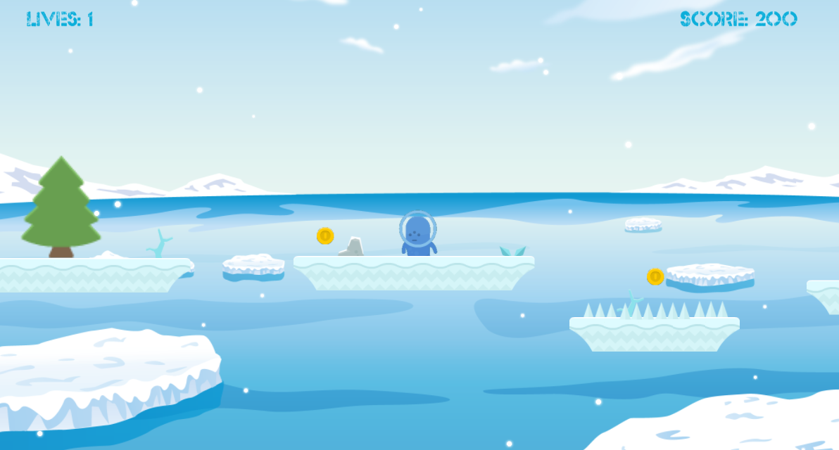

Level 2 Game Play

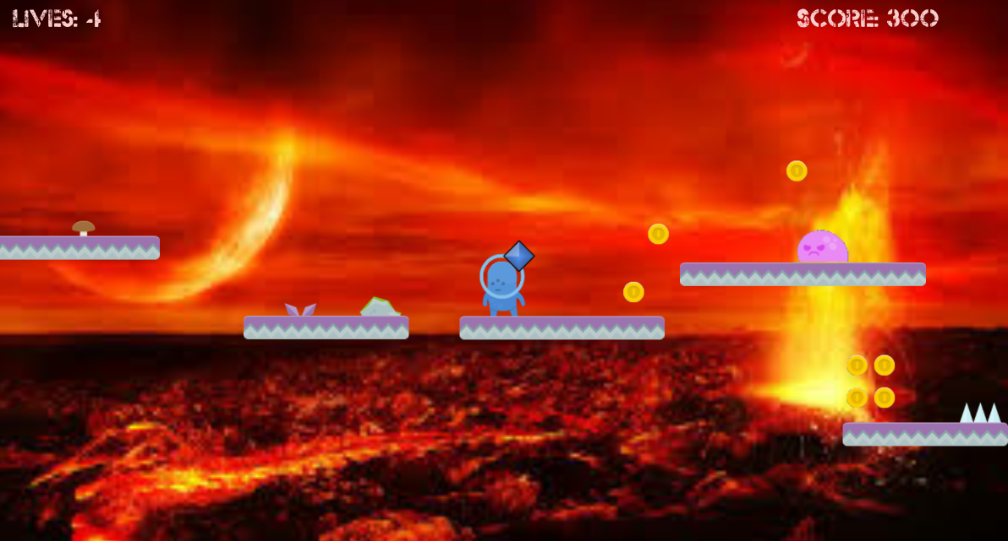

Level 3 Game Play

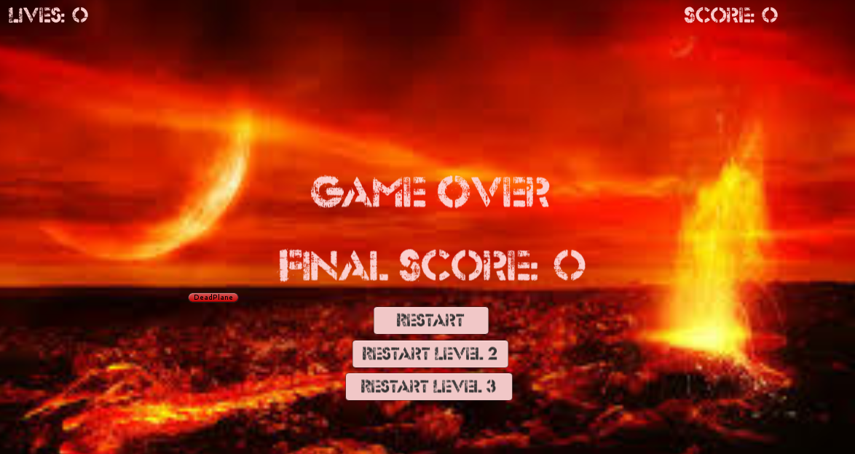

Game Over Screen (Background changes depending on the level)

1. **Levels**

* Level 1: The player is in the mountains and the platforms are filled with pink sticky aliens, he need to jump over them to make them flat and don’t push him down. The objective is to collect as much coins as possible and finish the level.
* Level 2: This time the player is in some frozen platforms, he need to take extra care because is slippery. The enemies here are ghosts that get fat when the player is detected. As level 1 the objective is make your way into the level gathering coins and dying as less as possible.
* Level 3: The player is located in a very warm lava setting. The level is full of flying and land based enemies. The flying enemies cannot be killed, so they must be avoided. The plater should collect as many coins as possible and make it to the end of the level to win the game!

1. **Characters / Vehicles**

*You are a blue alien trying to survive in an exotic planet. The game is played from an orthographic side view (2D).*

1. **Enemies**

*The enemies will be placed around the levels for the player to destroy or avoid. Hitting the enemies will result in the player using up one of their lives.*

*Jelly monster – they will not hurt you but they will try to throw you off the platform, you can also use them as impulse to jump.*

*Ghost – if they touch you they will take your life, you can kill them jumping over. The ghost will get fat and angry if they see you, take care.*

*Flying Bat – Flies in a circular motion and cannot be killed by the player. The bat can fly through objects and will kill the player on contact.*

*Flying Ship – The Jelly monsters have taken control of flying saucers and also fly in a circular pattern like the bats. The player will not die when hitting the ships, but the ships can hit the player off of the platform.*

1. **Weapons**
2. **Scripts**

*Scripts within the game:*

CheckPoints – Help respawn in the new checkpoints.

EnemeyController – Control’s enemy behavior.

GameController – Control the score and lives score and the menu.

KillerScript – Destroy any object that touch the death plane.

PlayerController – Control the player behavior.

EnemeyGhostController – Control’s enemy ghost behavior.

EnemeyShipController – Control’s enemy ship behavior.

ParticleController – Control’s the particles system when the player shoot its gun.

PlayerLevel2Controller – Control the player behavior.

PlayerLevel2Controller – Control the player behavior.

1. **Scoring**

*The player can increase their score by 100 points collecting coins.*

1. **Sound Index**

*Sounds within the game:*

*Aww.mp3 – Sound when you die*

Blue\_Dot\_Sessions\_-\_04\_-\_Heather.mp3 – Game soundtrack.

Coin.wav – sound when you pick up a coin.

Enemy.mp3 – sound when you jump into an enemy.

Jump.mp3 – sound when you jump.

Ghost.wav – sound when a ghost is killed.

1. **Art / Multimedia Index**

*Art within the game:*

C:\Users\Diego\AppData\Local\Microsoft\Windows\INetCache\Content.Word\EnemyMove_1.png*Enemy*

*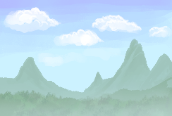 Background*

*C:\Users\Diego\AppData\Local\Microsoft\Windows\INetCache\Content.Word\coin.pngCoin*

*Hero*

*C:\Users\Diego\AppData\Local\Microsoft\Windows\INetCache\Content.Word\gameEnd.fw.pngNext level button*

*C:\Users\Diego\AppData\Local\Microsoft\Windows\INetCache\Content.Word\plant1.pngPlant 1*

*C:\Users\Diego\AppData\Local\Microsoft\Windows\INetCache\Content.Word\plant2.fw.pngPlant 2*

*C:\Users\Diego\AppData\Local\Microsoft\Windows\INetCache\Content.Word\plant3.pngPlant 3*

*C:\Users\Diego\AppData\Local\Microsoft\Windows\INetCache\Content.Word\plant4.pngPlant 4*

*Background level 2*

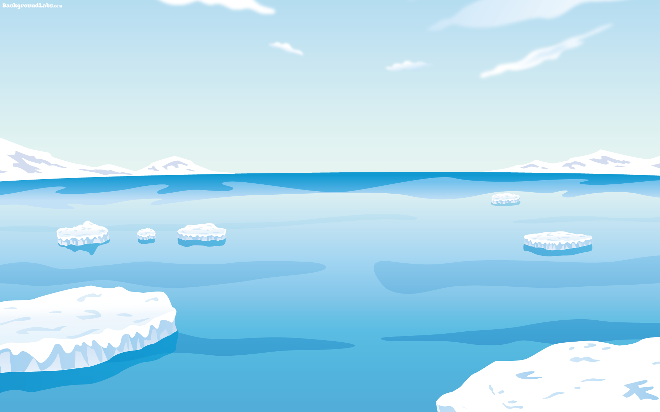

*Ghost*



*Tree 1*



*Tree 2*



*Plant 1*



*Plant 2*



*Rock 1*



*Rock 2*



*Spikes*



*C:\Users\Jason\Desktop\GIT\GameFP\Unity2D_Platformer_Alien\Assets\Sprites\Level_3\flyDead.pngEnemy Fly (Flying Bat)*

*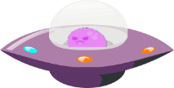Enemy Ship (Flying Ship) – Controlled by Jelly.*